Wireframe Document

Heart Disease Diagnostic Analysis

**Revision Number - 1.2**

**Last Date of Revision - 08/02/2024**

**Ahamed Ajas S**

**Afrin S**

**Document Control**

|  |  |  |  |
| --- | --- | --- | --- |
| **Date** | **Version** | **Description** | **Author** |
| 21/01/2024 | 1.0 | Introduction, Problem Statement | Ahamed Ajas S  Afrin S |
| 21/01/2024 | 1.1 | Dataset Information, Architecture Description | Ahamed Ajas S  Afrin S |
| 21/01/2024 | 1.2 | Final Revision | M |
|  |  |  |  |

**We Performed Exploratory Data Analysis on Jupyter Notebook and then created a Power BI Desktop Dashboard.**

# What Kind of Population do we have?

# 

# 

* + 0.5 non-defaulters and 1.0 Defaulters
  + Females have higher count than men.

1. **Males or Females who are more likely to default next month ?**

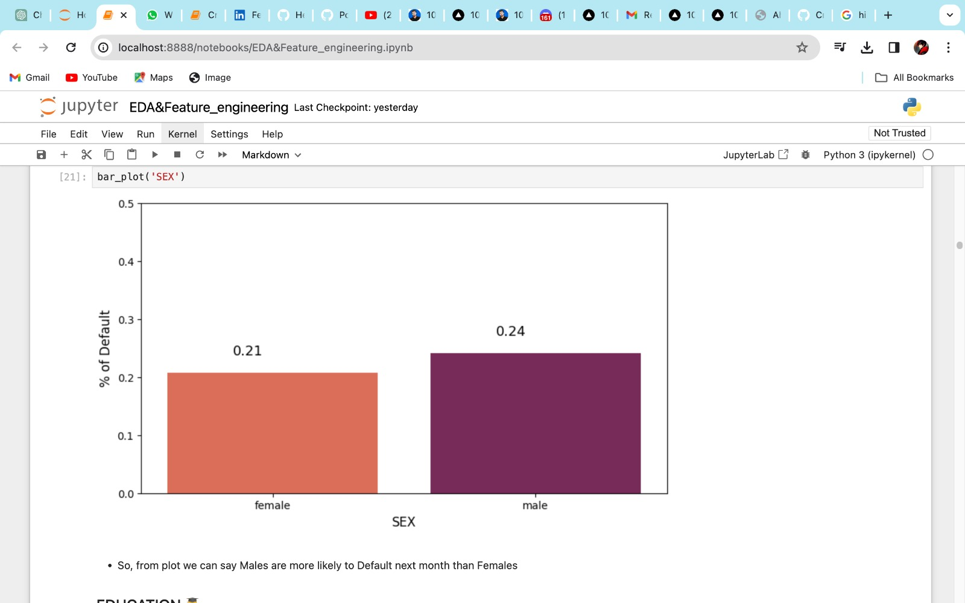

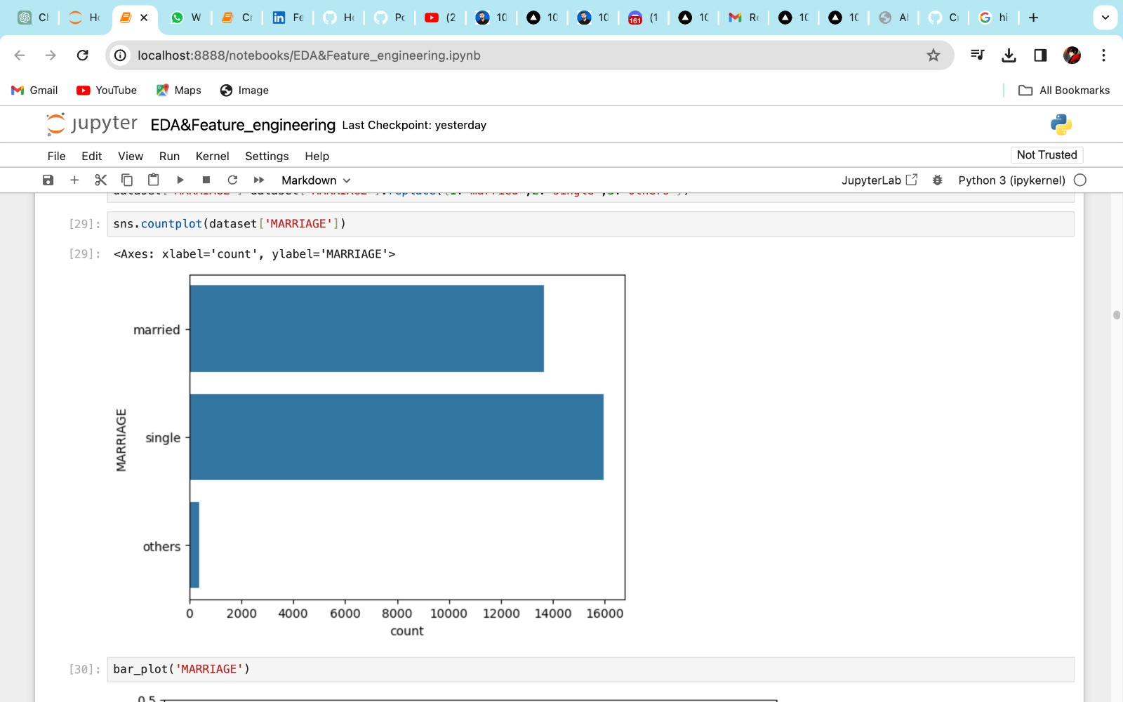

* So, from plot we can say Males are more likely to Default next month than females
* Single Category People are highly default payers

1. **Which level of education shows a higher likelihood of default?**

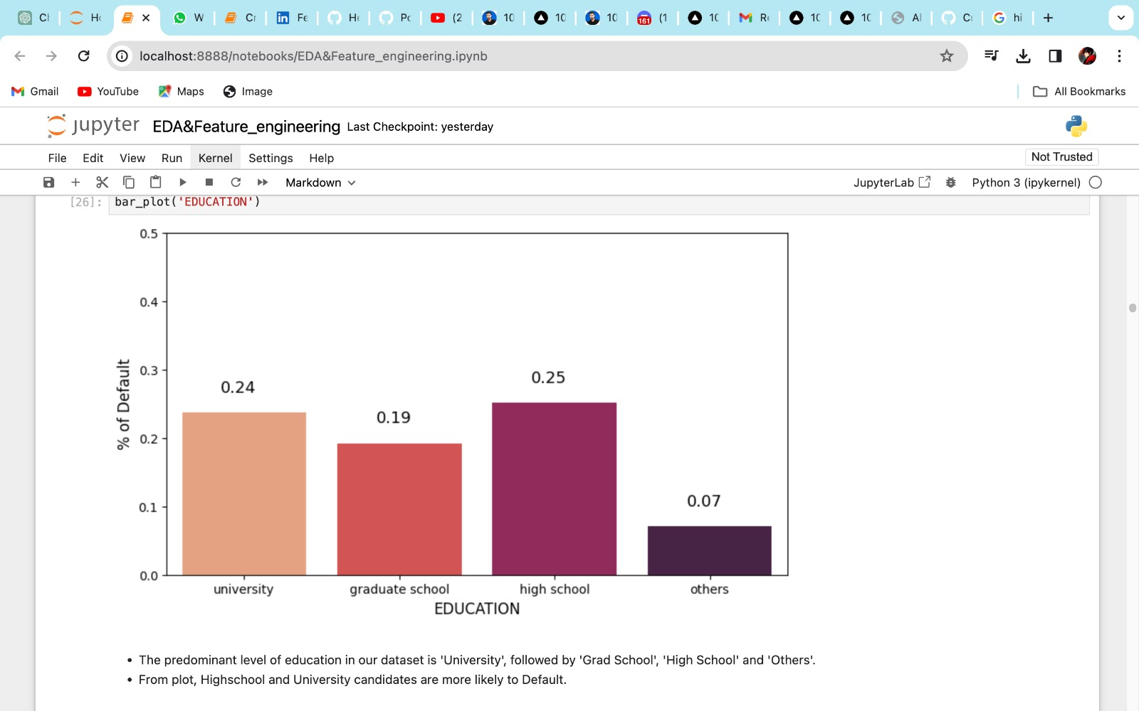

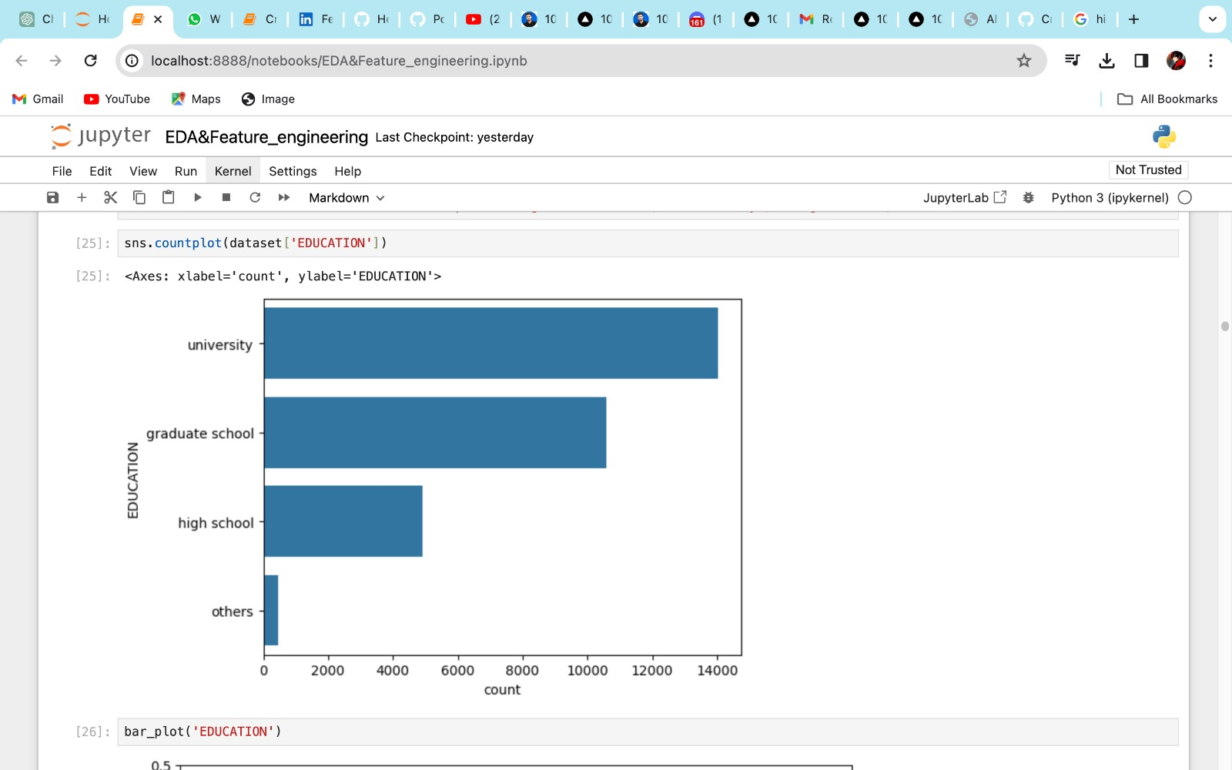

* The predominant level of education in our dataset is “University”, followed by ‘ Grade School’, ‘High School’ and ‘Others’.
* From plot, Highschool and University candidates are more likely to Default.

1. **Visualizing the distribution of limit balances according to months.**

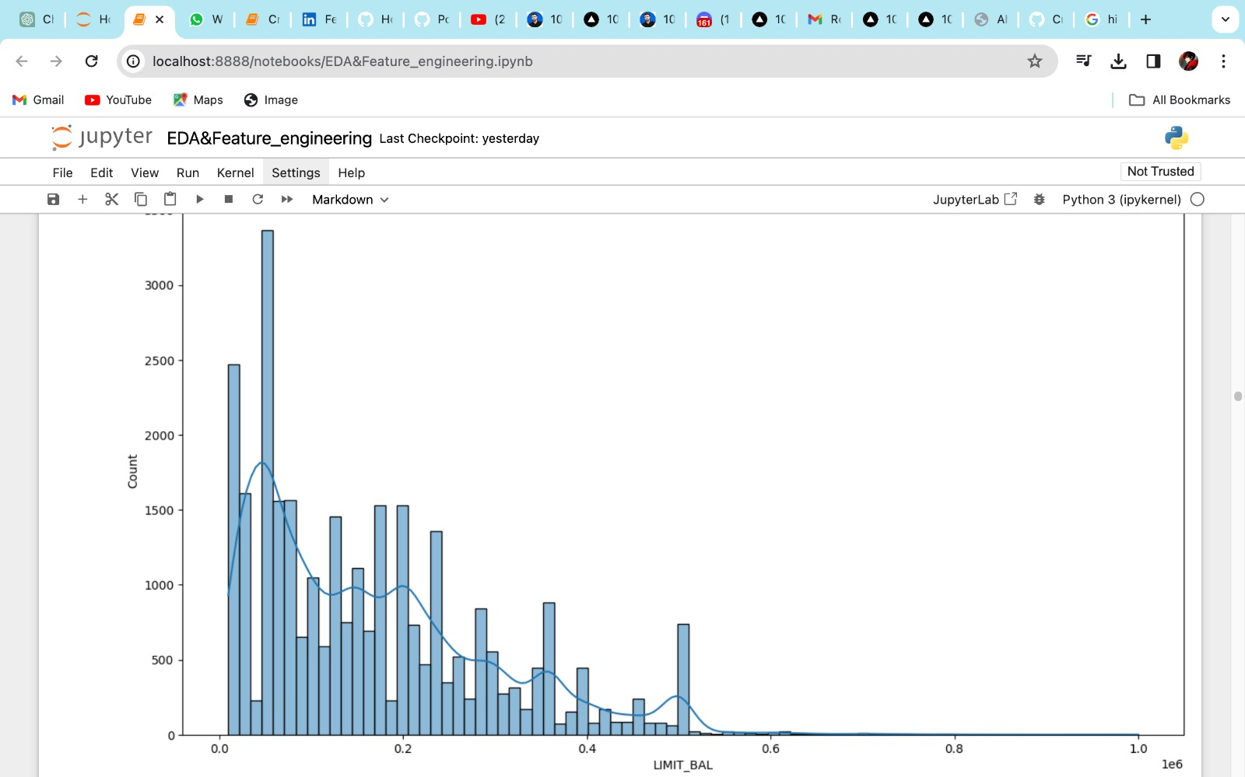

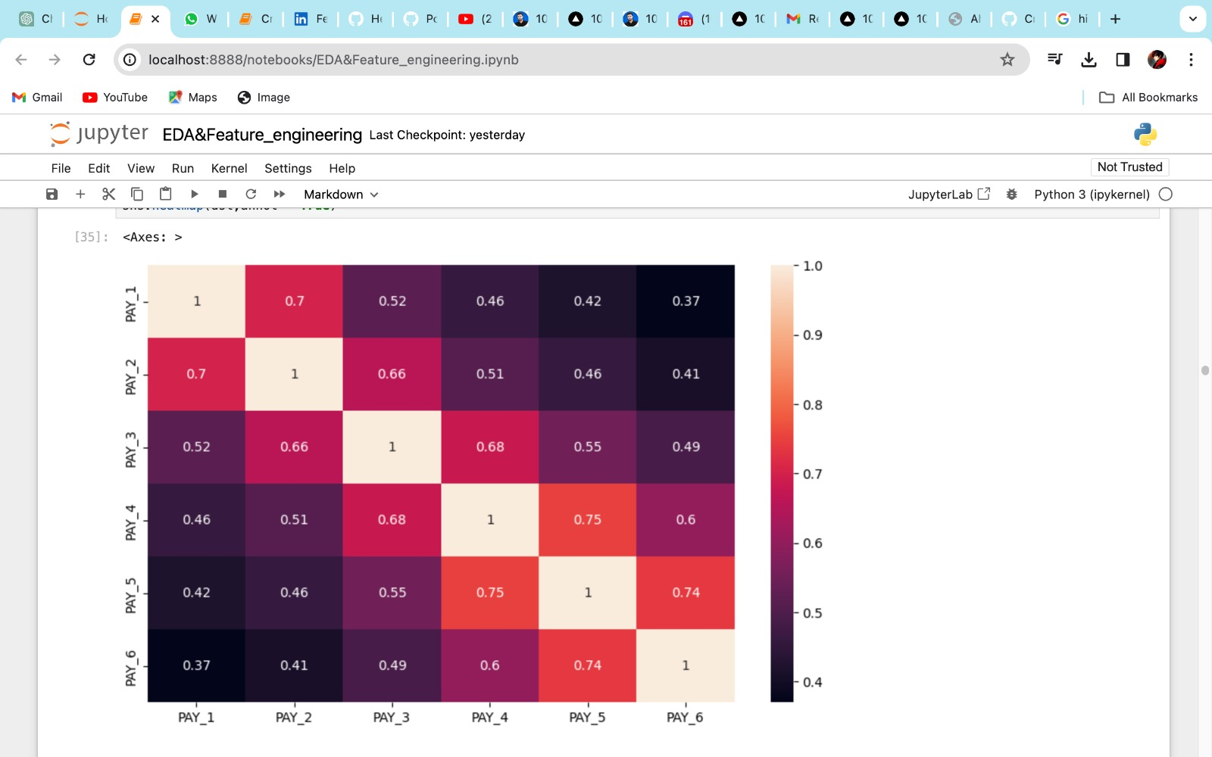

* It represents the maximum amount a credit card holder can borrow

1. **Is there a noticeable trend in default rates based on credit limits in the dataset?**

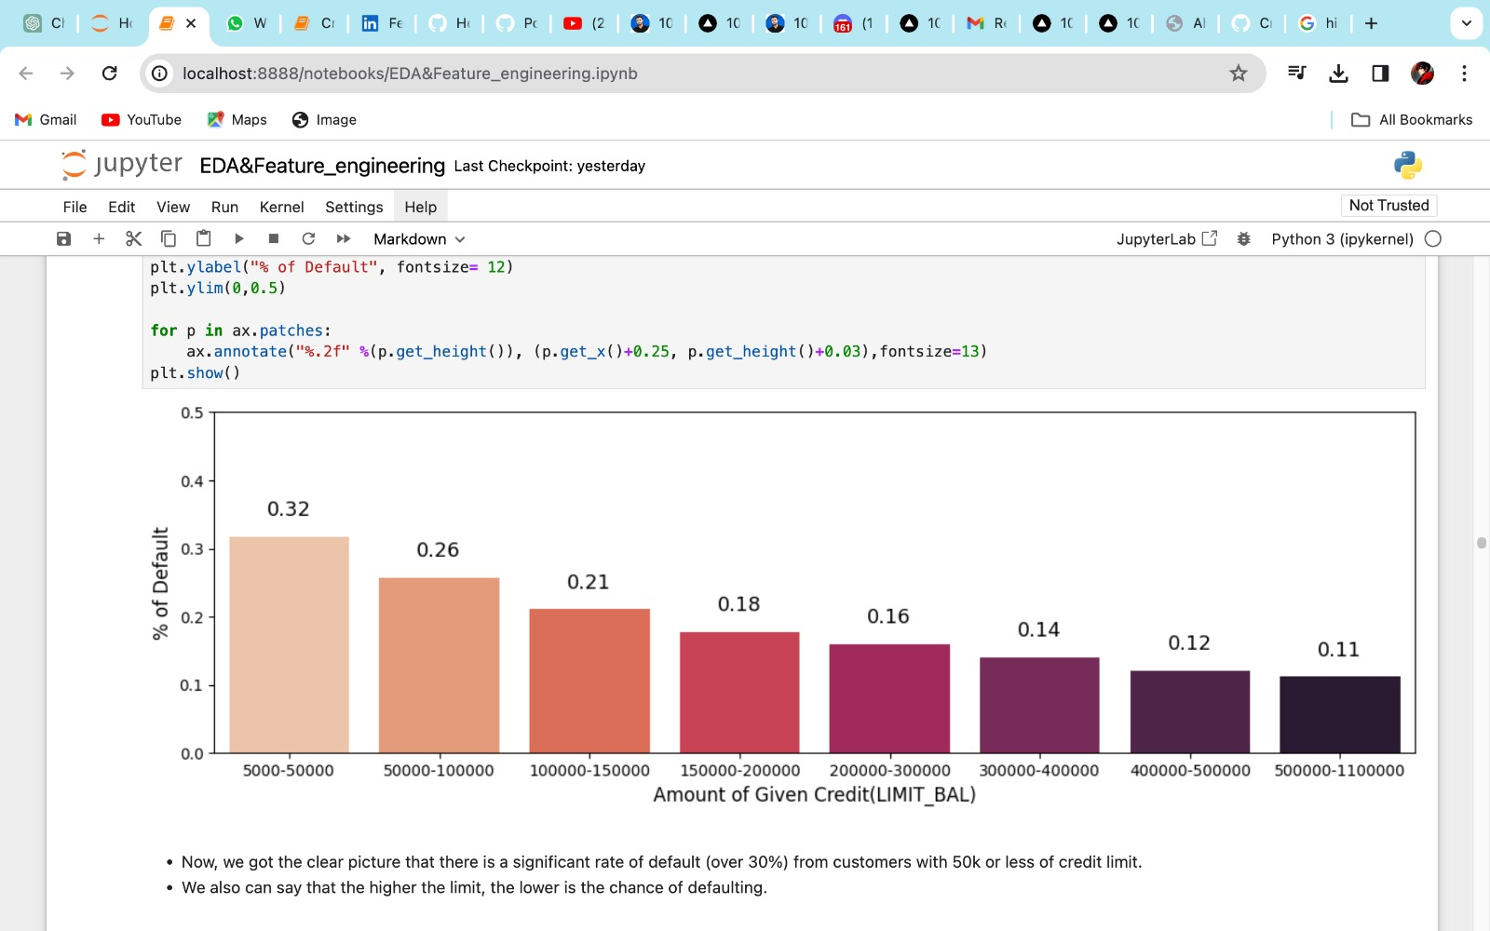

* Now, we got the clear picture that there is a significant rate of default (over 30%) from customers with 50k or less of credit limit.
* We also can say that the higher the limit, the lower is the chance of defaulting